**CHAPTER III**

**METHODS AND PROCEDURES**

This chapter explaints the procedures needed to be used in research. This chapter discusses the research design, respondents of the study, data gathering tools, data gathering procedures, and system development which is essential to the study. This describes the procedure that must be followed in order to create the flow of system.

**Research Design**

The researchers followed a series of steps to arrive at the main target or objective, which was done by the practical understanding of a suitable technique. This part of the study will discuss the procedures to be used by the researchers to be able to acquire the needed data and details for the study. Furthermore, the output of the research will be fully developed once fulfilled.

Quantitative data will be conducted since the research involves numerical data. The researchers will be using a descriptive type of research to gather information. Descriptive research wherein details are accurately collected without altering their background. The analysis of the population sample will help in the formation of the system.

The descriptive type of research is an appropriate choice for the topic since this investigates one or more variables. In contrast to experimental research, which the researcher does not influence or manipulate the variables, but rather observes and measures them.

**Respondents of the Study**

To gather the necessary data, the researchers will use a non-probability sampling technique. ~~Purposive sampling would be used specifically because it is the most efficient method of data collection for the study.~~ According to ~~Etikan (2017),~~ the sampling design is based on the judgment of the researcher as to who will provide the best information to succeed for the objectives of the study. By using the strategy, the process has the advantage of being time-saving and effective with the study.

Consequently, the researchers want to access a particular group of people that will be needed with the researchers’ study.

**Table 1. Respondents of the Study**

|  |  |
| --- | --- |
| **Respondent Category** | **No. of Respondents** |
| Users | 15 |
| Web Development expert | 10 |
| Total | 25 |

Table 1 shows the total number of the population of the given respondents needed for the study. It has three categories which are preschool teachers, parents, and web development experts.

The respondents of the study are comprised of fifteen (15) users and five (10) web-development experts totaling into twenty (25) overall respondents. The users are composed of preschool teachers and parents and the chosen experts must have atleast five years of work experience as a software or web developer, exhibits prowess in programming and web design, and adept in the fields of software and web development.

**Data Gathering Tools**

The researchers will utilize multiple tools to gather important data which will help in the process of creating both the research and the system itself. Such data gathering tools shall be used to gather relevant information thus, aiding the researcher’s progress.

An interview is the activity between an interviewer and interviewee wherein an interactive conversational exchange between both participants in which the interviewer’s questions intended to gather information are answered by the interviewee. The interview will be used to garner relevant information in relation to the proposed system to be developed.

The internet contains a plethora of information about almost anything including many scholarly works. An internet research is to be conducted by the researchers in order to collect data from related studies posted on the internet. The information that will be gathered from the online based resources will be beneficial during the research.

A library research makes use of the articles, researches, and journals that are shelved and can be easily accessed in a library. Conducting a library research will also be useful to the researchersas they can browse for studies about computer-assisted instruction and education-based systems and other informative resources. Finding similar studies to the current research will be used as references to further improve on both the research and the system.

A survey is a set of questions with a choice of answers targeted at a specific population used to gather information from the respondents. The survey will be utilized to gather feedback from using the finished system.

**Data Gathering Procedures**

The researchers reached out to the client and contacted them through a social media platform. This was done to look for possible suggestions and recommendations with regards to the system to be developed.

The researchers then began to look for journals and related studies online with the use of their personal computers at home. Browsing the internet is used to collect reliable information helped in correlating supporting data for the research.

Even after the extensive search of related information on the internet, the researchers proceeded to go to the school library in Pamantasan ng Cabuyao. The purpose was to look for more reliable resources like previous studies and researches which prove to be more credible than other online references.

The researchers will then gather data from the respondents via a survey. The survey will utilize the Likert scale as its survey scale which is comprised of five possible responses on each questionnaire item depending on the type of questions the researchers will impose on their respondents.

**Data Analysis Plan**

The data that will be collected from the survey shall be presented in a tabular format. The scale to be used for the questionnaire is the Likert scale. The Likert scale assumes that the intensity of an attitude is linear and uses five to seven linear responses to assume the measure of an attitude. The questionnaire will have five (5) options to choose from each with its corresponding numeric code as shown below.

Option Code Strongly Agree (SA) 5 Agree (A) 4

Undecided (U) 3

Disagree (D) 2

Strongly Disagree (SD) 1

In determining the average responses across the respondents, the median will be used to evaluate the average scores. The median and percentage will be used as the main statistical tools for tallying the responses from the questionnaire.

**System Development**

The methodology to be used in developing the proposed system is the Scrum agile methodology. The Scrum agile methodology is an is a widely used framework in the development of system softwares that is both lightweight and easy to understand. It is composed of several phases which are Initiate, Plan and Estimate, Implement, Review and Retrospect, and Release.

During the Initiate phase, the researchers will have to create a summary of all the requirements and features that will be implemented to the proposed system. The overall design of the proposed system will be formulated by the researchers.

In the Plan and Estimate phase, the researchers will start to layout the activities for the proposed system. The researchers will establish the design for every activity to be accomplished.

In the Implement phase, the researchers will begin to fulfill the activities planned in the previous phase. The researchers will have a time alotted for finishing each activity.

In the Review and Retrospect phase, the finished features from doing an activity will be will be reviewed and if there are tasks not finished in time from that activity, it will be included in the next activity. The researchers will also reflect upon the challenges from the previous activities and improve on the future activities to be done.

The Release phase is when the system is completely done and the researchers are ready to send it over to the client. The researchers will also reflect upon the challenges in the whole development process that can be improved on the future projects.

A class diagram is a type of diagram which is part of a unified modeling language (UML) that defines and gives the overview and structure of the system in terms of classes, methods, attributes, and the relationship amongst the different classes.

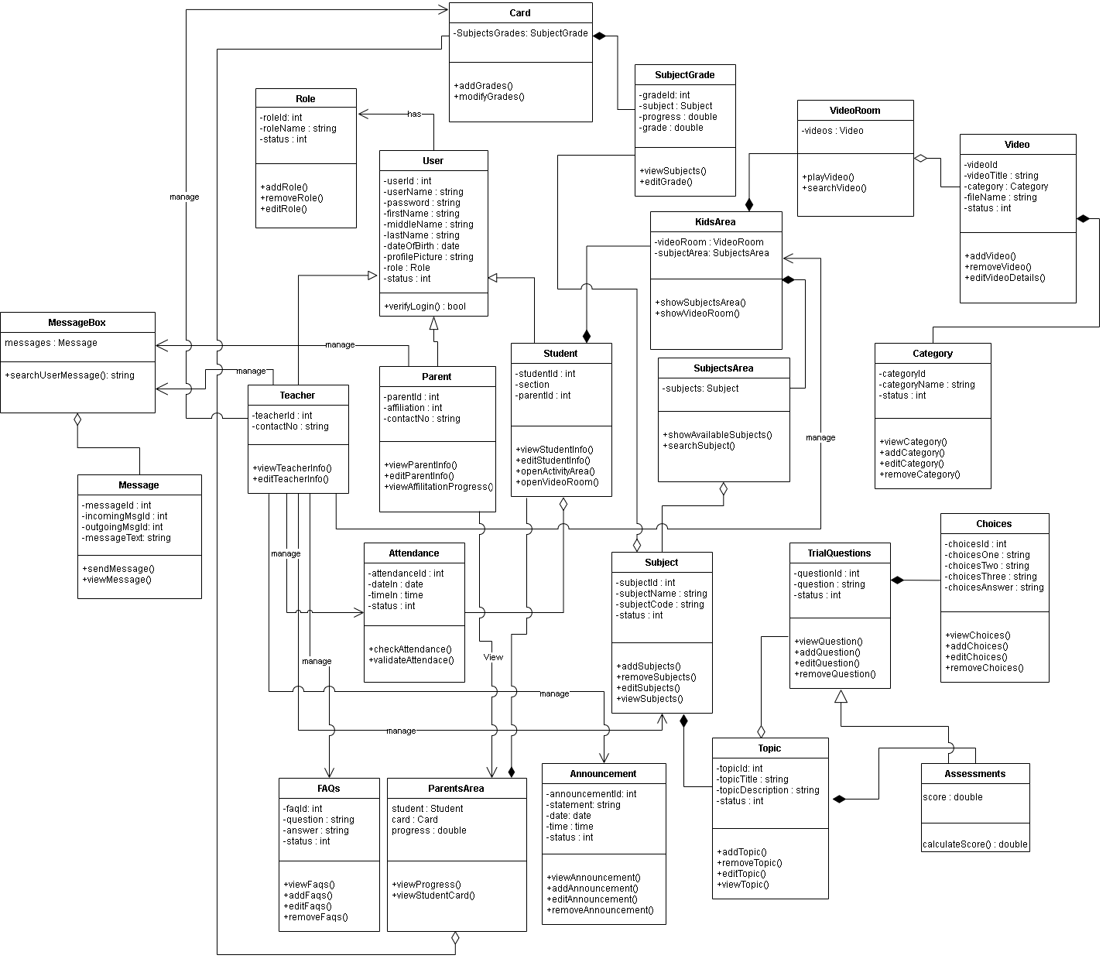

**Figure 1. Class Diagram**

Figure 1 shows all the classes that will be used on the Web-based Computer-Aided Instruction for Nursery Students and their corresponding methods and the relationships and the attributes of each class in the diagram. The diagram consists of class for Card, Role, User, Teacher, FAQs, Attendance, Parent, Student, ParentsArea, Announcement, Subject, Subjects Area, Subject Grade, KidsArea, Video, VideoRoom, Category, TrialQuestion, Topic, Assessments, and Choices.

The parents, student, and teacher inherit the User table’s instances or properties which provide the needs for users, such as username, password, first name, middle name, last name, sex, date of birth, profile, picture, role, and status of an account. The parent has property affiliation, email, and contact number. The teacher has properties of email and contact number. While the student contains the section and their parent.

The kid’s area class has a video room and subject area. While video room class has videos and subject area has subjects. The video class contains a property video title, category, and file name. The subject class is composed of topics and has a property of subject name and subject code. While the topic class contains a topic title and topic description. The assessment class has score property and inherits all properties of the trial question class that are composed of choices and has a property of question.

The teacher manages subjects, announcements, FAQs, student cards, and attendance of the student. The parent has an access to view the parent’s area class that contains the student information, student card, and progress. They both have an access to their message box to contact each other if they have questions. It depicts the system's overall presentation, as well as the various objects included in the proposed system, as well as their relationships and how objects interact with one another.

Use case diagrams are a visual representation of a system's requirements, including internal and external factors. The roles of the actors are portrayed across these diagrams. The purpose of this diagram is to provide an overview of the actors and their roles, functionalities, as well as dependencies presented in the diagram.

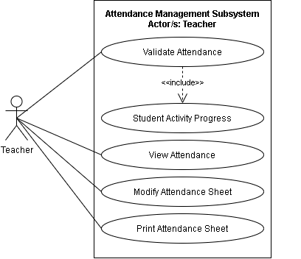

**Figure 2. A Use Case Diagram for Attendance Management Subsystem**

Figure 2 shows the Use case diagram for the Attendance Management Subsystem. The illustration shows the capabilities of the teacher. The teacher can validate attendance which includes the student’s activity progress, student’s attendance, modify attendance sheet, and print attendance sheet.

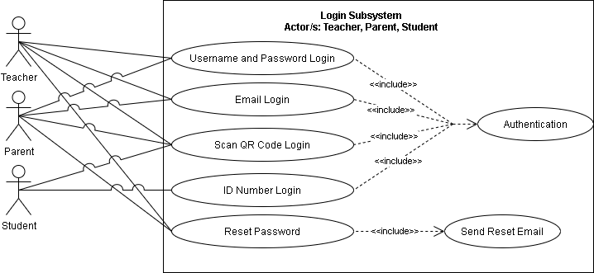Apply generalization (inheritance) to parent and teacher actors

**Figure 3. A Use Case Diagram for Login Subsystem**

Figure 3 shows the Use case diagram for the Login Subsystem. The illustration shows the capabilities of teachers, parents, and students. The teacher and parents have access to username, password, e-mail, QR code, and reset password which is the primary authentication of the system. Otherwise, the student can only access the system by scanning the QR code and by its unique ID number.

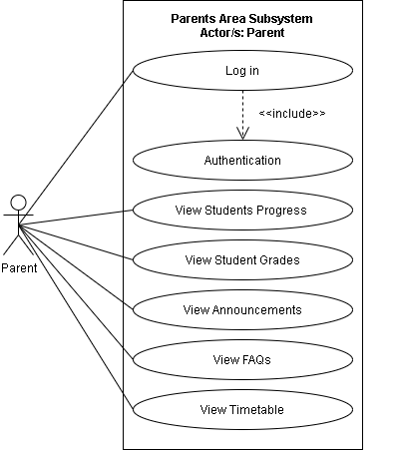

**Figure 4. A use case diagram for Parents Area Subsystem**

Figure 4 shows the Use case diagram for the Parents Area Subsystem. The illustration shows the capabilities of parents. The parents have access to Log in which includes authentication, student’s progress, student’s grades, view announcements, view FAQs, and view Timetable.

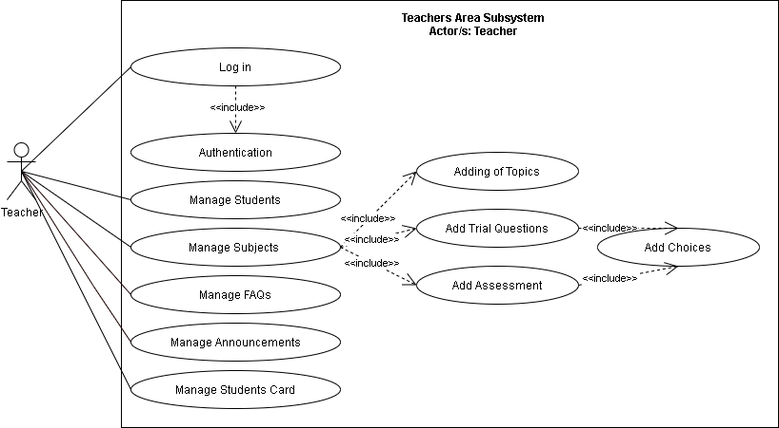

**Figure 5. A Use Case Diagram for Teachers Area Subsystem**

Figure 5 shows the Use case diagram for the Teachers Area Subsystem. The illustration shows the capabilities of teachers. The teachers have access to Log in which includes authentication. Manage of Subjects which includes adding topics, trial questions, and assessment. Teachers can also manage FAQs, manage announcements, and manage student cards.

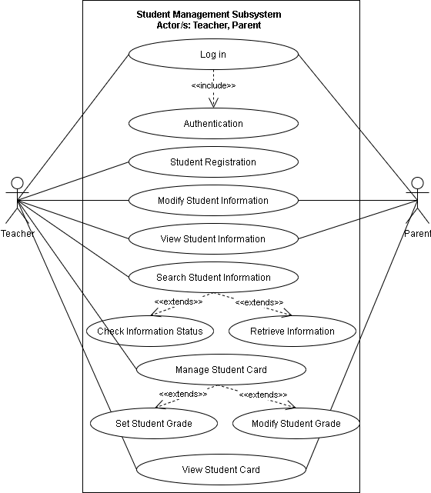

**Figure 6. A use case diagram for Student Management Subsystem**

Figure 6 shows the Use case diagram for the Student Management Subsystem. The illustration shows the capabilities of teachers and parents. The teachers have access to Log in which includes authentication, student registration, modify student information, view student information, search student information, manage student cards, and view student card. Otherwise, the parent has access to Log in which includes authentication, modify student information, view student information, and view student card.

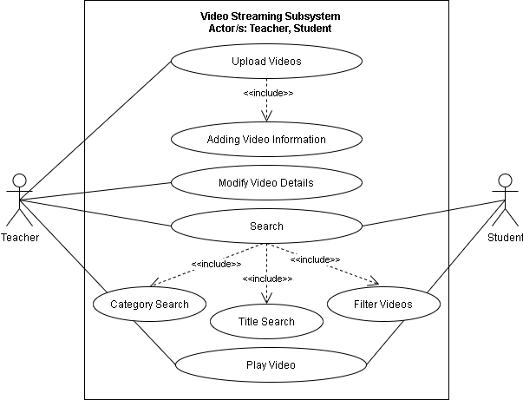

**Figure 7. A use case diagram for Video Streaming Subsystem**

Figure 7 shows the Use case diagram for the Video Streaming Subsystem. The illustration shows the capabilities of teacher and student. The teachers can upload videos that include its information, modify video details, search video and play video. Otherwise, the student can only search for video and play videos.

**Table 2. Use case analysis for Attendance Management Subsystem**

|  |  |  |  |
| --- | --- | --- | --- |
| **Actor/s** | **Event** | **Trigger** | **System Response** |
| **Teacher** | Validate Attendance | Teacher logs in | Display log-in form |
| **Teacher** | View Attendance | Teacher views the attendance | Display the attendance |
| **Teacher** | Modify Attendance Sheet | Teacher modifies the attendance sheet | Update the attendance sheet |
| **Teacher** | Print Attendance Sheet | Teacher prints attendance sheet | Print the attendance sheet |

**Table 3. Use case analysis for Login Subsystem**

|  |  |  |  |
| --- | --- | --- | --- |
| **Actor/s** | **Event** | **Trigger** | **System Response** |
| **Teacher, Parent** | Username and Password Login | Teacher or Parent enters username and password login | Display username and password form |
| **Teacher, Parent** | E-mail Login | Teacher or Parent enters e-mail login | Display e-mail form |
| **Teacher, Parent, Student** | Scan QR Code Login | Teacher, Parent or Student scans QR code to login | Display the QR code form |
| **Student** | ID Number Login | Student enters ID number to login | Display the ID number form |
| **Teacher, Parent** | Reset Password | Teacher or Parent resets the password of the student | Shows a reset password field |

**Table 4. Use case analysis for Parent Subsystem**

|  |  |  |  |
| --- | --- | --- | --- |
| **Actor/s** | **Event** | **Trigger** | **System Response** |
| **Parents** | Log in | Parent logs in | Display log-in form |
| **Parents** | View Students Progress | Parent views students progress | Display students progress |
| **Parents** | View Students Grades | Parent views students grade | Display students grade |
| **Parents** | View Announcements | Parent views announcements | Display announcement |
| **Parents** | View FAQs | Parent views FAQs | Displays the FAQS |
| **Parents** | View Timetable | Parent views timetable | Display the timetable |

**Table 5. Use case analysis for Teachers Area Subsystem**

|  |  |  |  |
| --- | --- | --- | --- |
| **Actor/s** | **Event** | **Trigger** | **System Response** |
| **Teacher** | Log in | Teacher logs in | Display login form |
| **Teacher** | Manage Students | Teacher manages student | Update the students list |
| **Teacher** | Manage Subjects | Teacher manages subjects | Updates students subject |
| **Teacher** | Manage FAQs | Teacher manages FAQ’s | Update the FAQs |
| **Teacher** | Manage Announcement | Teacher manages announcement | Update the announcement |
| **Teacher** | Manage Students Card | Teacher manages students card | Update the students card |

**Table 6. Use case analysis for Student Management Subsystem**

|  |  |  |  |
| --- | --- | --- | --- |
| **Actor/s** | **Event** | **Trigger** | **System Response** |
| **Teacher, Parent** | Log in | Teacher or Parent logs in | Display login form |
| **Teacher** | Student Registration | Teacher registers a student | Saved an information of student |
| **Teacher, Parents** | Modify Student Information | Teacher or Parent modifies student’s information | Update the student information |
| **Teacher, Parents** | View Student Information | Teacher or Parent views the student’s information | Display the student information |
| **Teacher** | Search Student Information | Teacher searches student’s information | Display Check Information Status and Retrieve Information |
| **Teacher** | Manage Student Card | Teacher modifies student’s card | Displays setting of student grade and modifying of student grade |
| **Teacher, Parent** | View Student Card | Teacher or Parent views student card | Display student card |

**Table 7. Use case analysis for Video Streaming Subsystem**

|  |  |  |  |
| --- | --- | --- | --- |
| **Actor/s** | **Event** | **Trigger** | **System Response** |
| **Teacher** | Upload Videos | Teacher uploads video | Uploads video to the system |
| **Teacher** | Modify Video Details | Teacher modifies video details | Updates video details |
| **Teacher, Student** | Search | Teacher or Student searches video | Displays Category Search, Title Search and Filter Videos |
| **Teacher, Student** | Play Video | Teacher or Student plays video | Runs the video |

The activity diagram presents the overall workflow of the activities included in the system in a graphical format. This gives a visual representation of the step by step process of activities including iterations and/or concurrent operations within the workflow.

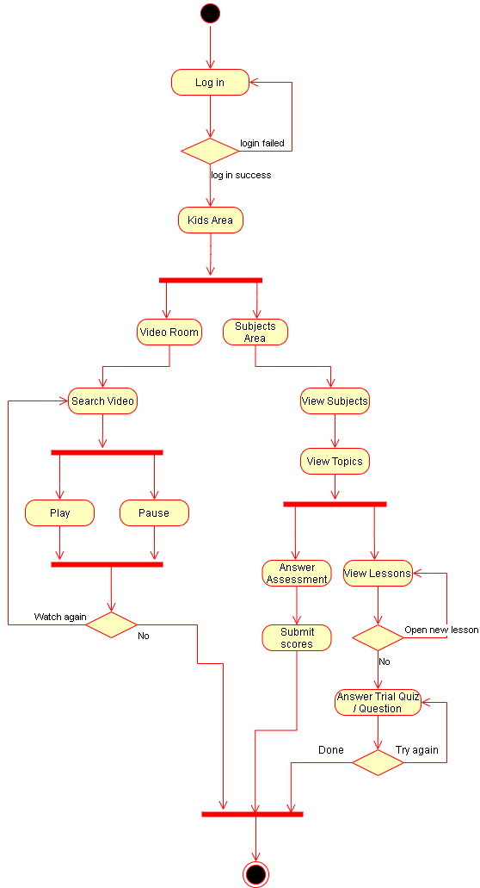

**Figure 8. Activity Diagram for Kid’s Area Activity**

Figure 8 shows the Activity Diagram for Kid’s Area Activity. The student will login, the system will authenticate if the student has successfully entered and if not the system will back to the login area. If the student has successfully login, the system now proceeds to Video Room and Subject Area.

In Video Room, the student has access to Search Video, wherein the student can play and pause the video. If the student want to watch again, the system will reiterate to Search Video activity. Otherwise, the activity will exit.

In Subject Area, the system will proceeds in showing of subjects and its topic. The student may choose to answer an assessment or view the lesson. After the end of each lesson, the system will proceed in trial quiz/question area wherein the student shall answer the question correctly otherwise, the system will repeat until the question is correctly answered.

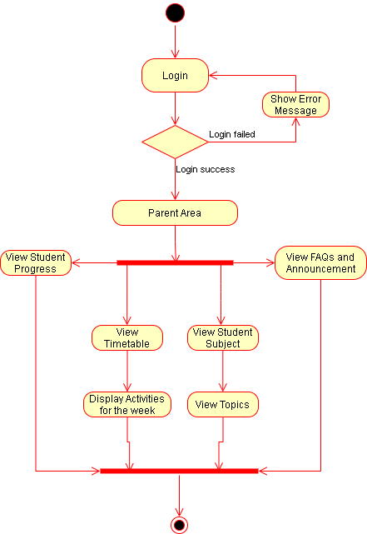

**Figure 9. Activity Diagram for Parents Activity**

Figure 9 shows the Activity Diagram for Parents Activity. The parent will login, the system will authenticate if the parent has successfully entered and if not the system will back to the login area. If the parent has successfully login, the system now proceeds to Parents area wherein the parents can view the student progress, FAQs and announcement, timetable, student subject, display activities for the week and view topics.

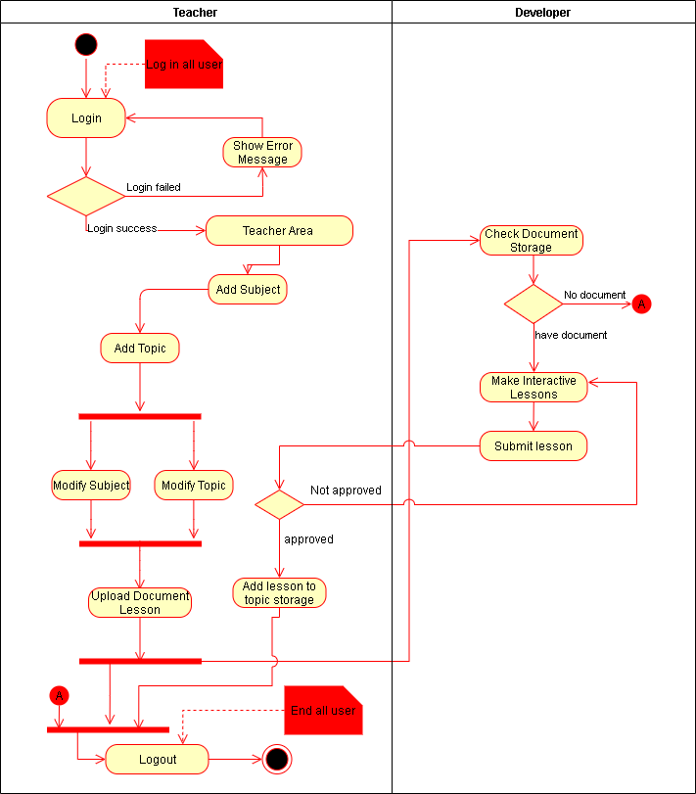

**Figure 10. Activity Diagram for Lesson Adding**

Figure 10 shows the Activity Diagram for Lesson Adding. The teacher will login, the system will authenticate if the teacher has successfully entered and if not the system will back to the login area. The system now proceeds to Teacher Area wherein the teacher can add a subject and its topic. The Subject and Topic can be modified and proceeds to uploading of its documentation. After the teacher uploads a document, the developers of the system can check the Document Storage if there is a document uploaded, the system will proceed to creating of interactive lessons otherwise the system will exit. Every submission of lesson has a validation of approval before proceeding. If the lesson is not approved, the system will repeat until it is approved. Successfully approved lessons can now be added to the topic storage.

The entity-relationship diagram shows the entities and their relationships on a given database. The purpose of this diagram is to ensure a good database design.

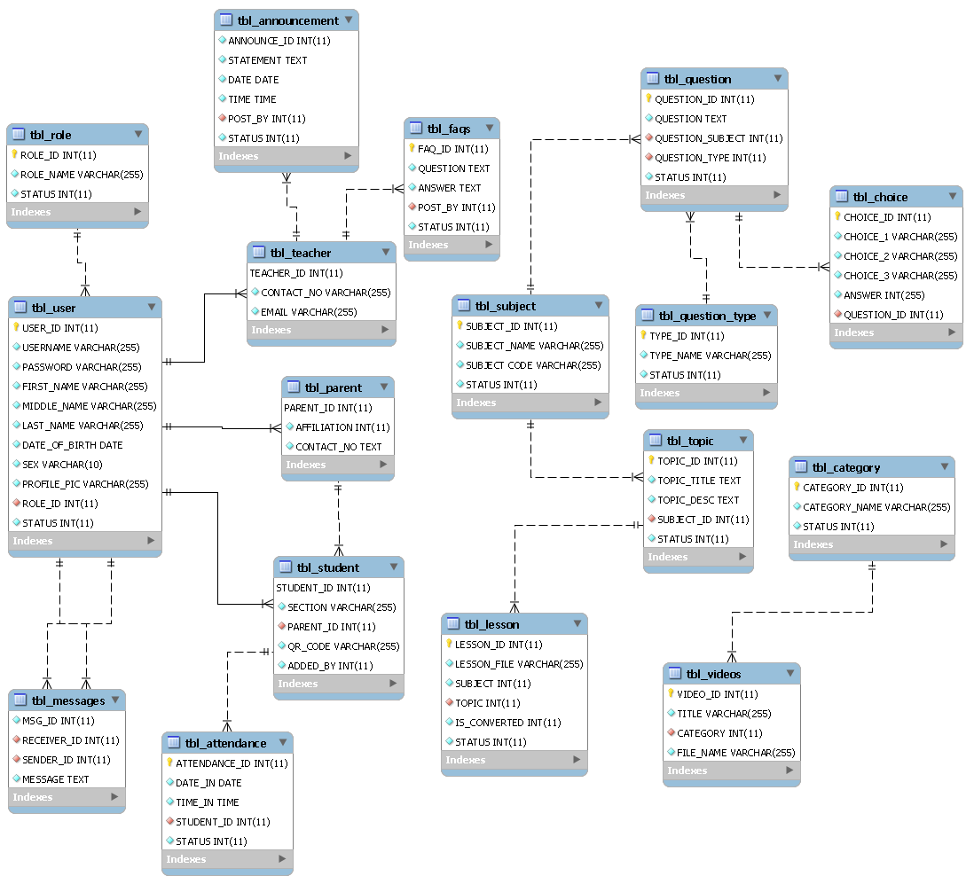

**Figure 11. Entity-Relationship Diagram for Web-based Computer Aided Instruction for Preschool**

ERD Discussion???

**Table 8. Data Dictionary of User**

|  |  |  |  |
| --- | --- | --- | --- |
| **Field** | **Data Type** | **Size** | **Description** |
| **ID** | INTEGER | 11 | ID of user |
| **userName** | VARCHAR | 255 | Username of the user |
| **password** | VARCHAR | 255 | Password of the user |
| **firstName** | VARCHAR | 255 | First name of the user |
| **middleName** | VARCHAR | 255 | Middle name of the user |
| **lastName** | VARCHAR | 255 | Last name of the user |
| **sex** | VARCHAR | 255 | Sex of the user |
| **dateOfBirth** | DATE | 11 | Date of birth of the user |
| **profilePicture** | VARCHAR | 255 | Profile picture of the user |
| **roleID** | INTEGER | 11 | Role of the user |
| **status** | INTEGER | 11 | Status of the user |

**Table 9. Data Dictionary of Messages**

|  |  |  |  |
| --- | --- | --- | --- |
| **Field** | **Data Type** | **Size** | **Description** |
| **messageID** | INTEGER | 11 | ID of message |
| **receiverID** | INTEGER | 11 | ID of receiver |
| **senderID** | INTEGER | 11 | ID of sender |
| **message** | TEXT |  | Message of the system |

**Table 10. Data Dictionary of Role**

|  |  |  |  |
| --- | --- | --- | --- |
| **Field** | **Data Type** | **Size** | **Description** |
| **roleID** | INTEGER | 11 | ID of the role |
| **roleName** | VARCHAR | 255 | Name of role |
| **status** | INTEGER | 11 | Status of role |

**Table 11. Data Dictionary of Teacher**

|  |  |  |  |
| --- | --- | --- | --- |
| **Field** | **Data Type** | **Size** | **Description** |
| **teacherID** | INTEGER | 11 | ID of the teacher |
| **contactNo** | VARCHAR | 255 | Contact number of the teacher |
| **email** | VARCHAR | 255 | Email of the teacher |

**Table 12. Data Dictionary of Parent**

|  |  |  |  |
| --- | --- | --- | --- |
| **Field** | **Data Type** | **Size** | **Description** |
| **parentID** | INTEGER | 11 | ID of the teacher |
| **affiliation** | VARCHAR | 255 | Contact number of the teacher |
| **contactNo** | VARCHAR | 255 | Email of the teacher |

**Table 13. Data Dictionary of Student**

|  |  |  |  |
| --- | --- | --- | --- |
| **Field** | **Data Type** | **Size** | **Description** |
| **studentID** | INTEGER | 11 | ID of the student |
| **section** | VARCHAR | 255 | Section of the student |
| **parentID** | INTEGER | 11 | Parent of the student |
| **qrCode** | VARCHAR | 255 | QR code of the student |
| **addedBy** | INTEGER | 11 | Contains the teacher handling an activity |

**Table 14. Data Dictionary of FAQS**

|  |  |  |  |
| --- | --- | --- | --- |
| **Field** | **Data Type** | **Size** | **Description** |
| **faqID** | INTEGER | 11 | ID of FAQ |
| **question** | TEXT |  | Question of FAQ |
| **answer** | TEXT |  | Answer of FAQ |
| **postBy** | INTEGER | 11 | Contains the teacher who posted FAQ |
| **status** | INTEGER | 11 | Status of FAQ |

**Table 15. Data Dictionary of Announcement**

|  |  |  |  |
| --- | --- | --- | --- |
| **Field** | **Data Type** | **Size** | **Description** |
| **announceID** | INTEGER | 11 | ID of announcement |
| **statement** | TEXT |  | Statement of the announcement |
| **date** | DATE |  | Date of the announcement |
| **time** | TIME |  | Time of announcement |
| **postBy** | INTEGER | 11 | Contains the teacher who posted the announcement |
| **status** | INTEGER | 11 | Status of announcement |

**Table 16. Data Dictionary of Attendance**

|  |  |  |  |
| --- | --- | --- | --- |
| **Field** | **Data Type** | **Size** | **Description** |
| **attendanceID** | INTEGER | 11 | ID of attendance |
| **dateIn** | DATE |  | Date of attendance |
| **TimeIn** | TIME |  | Time of attendance |
| **studentID** | INTEGER | 11 | ID of student |
| **status** | INTEGER | 11 | Status of the attendance |

**Table 17. Data Dictionary of Lesson**

|  |  |  |  |
| --- | --- | --- | --- |
| **Field** | **Data Type** | **Size** | **Description** |
| **lessonID** | INTEGER | 11 | ID of lesson |
| **lessonFile** | VARCHAR | 11 | File of lesson |
| **subject** | INTEGER | 11 | Subject of lesson |
| **topic** | INTEGER | 11 | Topic of lesson |
| **isConverted** | INTEGER | 11 | Contains the status of lesson being converted |
| **status** | INTEGER | 11 | Status of the lesson |

**Table 18. Data Dictionary of Question**

|  |  |  |  |
| --- | --- | --- | --- |
| **Field** | **Data Type** | **Size** | **Description** |
| **questionID** | INTEGER | 11 | ID of question |
| **question** | TEXT | 255 | Question of the FAQ |
| **questionSubject** | INTEGER | 11 | Subject of the questions |
| **questionType** | INTEGER | 11 | Type of questions |
| **status** | INTEGER | 11 | Status of the question |

**Table 19. Data Dictionary of Choice**

|  |  |  |  |
| --- | --- | --- | --- |
| **Field** | **Data Type** | **Size** | **Description** |
| **choiceID** | INTEGER | 11 | ID of choice |
| **choice1** | VARCHAR | 255 | First choice |
| **choice2** | VARCHAR | 255 | Second choice |
| **choice3** | VARCHAR | 255 | Third choice |
| **answer** | INTEGER | 11 | Answer of the choice |
| **questionID** | INTEGER | 11 | ID of question |

**Table 20. Data Dictionary of Question Type**

|  |  |  |  |
| --- | --- | --- | --- |
| **Field** | **Data Type** | **Size** | **Description** |
| **typeID** | INTEGER | 11 | ID of type |
| **typeName** | VARCHAR | 255 | Name of type |
| **status** | INTEGER | 11 | Status of type |

**Table 21. Data Dictionary of Subject**

|  |  |  |  |
| --- | --- | --- | --- |
| **Field** | **Data Type** | **Size** | **Description** |
| **subjectID** | INTEGER | 11 | ID of type |
| **subjectName** | VARCHAR | 255 | Name of subject |
| **subjectCode** | VARCHAR | 255 | Code of subject |
| **status** | INTEGER | 11 | Status of subject |

**Table 22. Data Dictionary of Topic**

|  |  |  |  |
| --- | --- | --- | --- |
| **Field** | **Data Type** | **Size** | **Description** |
| **topicID** | INTEGER | 11 | ID of topic |
| **topicTitle** | TEXT |  | Title of topic |
| **topicDesc** | TEXT |  | Description of topic |
| **subjectID** | INTEGER | 11 | ID of subject |
| **status** | INTEGER | 11 | Status of topic |

**Table 23. Data Dictionary of Videos**

|  |  |  |  |
| --- | --- | --- | --- |
| **Field** | **Data Type** | **Size** | **Description** |
| **videoID** | INTEGER | 11 | ID of video |
| **title** | VARCHAR | 255 | Title of video |
| **category** | INTEGER | 11 | Category of video |
| **fileName** | VARCHAR | 255 | File name of the video |

**Table 24. Data Dictionary of Category**

|  |  |  |  |
| --- | --- | --- | --- |
| **Field** | **Data Type** | **Size** | **Description** |
| **categoryID** | INTEGER | 11 | ID of category |
| **categoryName** | VARCHAR | 255 | Name of category |
| **status** | INTEGER | 11 | Status of category |